ABSTRACT

Gait recognition methodology used to recognize the person by their walking style. This technique is performed at a distance as video without the cooperation of the person who has to be recognized. Gait recognition have been used in various applications like access control, surveillance and forensics. Gait recognition strategies can be divided into three different techniques based on the setting as machine vision method, floor sensor method and wearable sensor method. In machine vision method, one or more cameras will be used for video capturing for processing the image transformation. This method is also termed as Gait Energy Image since the gait features were extracted from the blurring silhouette image got from the video. In floor sensor method, features of gait will be extracted from the images generated by the sensing floor. Wearable sensor method uses the techniques like gait kinematics, gait kinetics, and electromyography for extracting the gait signatures. Gait recognition is liable to variations, such as view angle, clothing, walking speed, shoes and carrying status. Convolution neural network is used to extract the high level features from less quality video by the following steps: preprocessing the video to obtain the input data. Extracting the features and comparing with pre trained neural network for recognition. A human acknowledgment and recognizable proof is viewed these days as an essential field of research. The most unique parts of human are the ear, odor, heartbeat, voice, the iris, periocular portion of eye, fingerprint, gait, sweat, face, etc,. Without the human interaction to identify a person is quite challenging with low resolution images. Gait recognition is one of the biometric technology which can be used to identify people without their knowledge. The proposed system uses Deep Convolutional Neural Network to extract the gait features of a person by training the neural network architecture with Gait Energy Image.
1.INTRODUCTION
1.1 Introduction
In our international and interconnected information society, there is an ever-growing need to authenticate and identify individuals. Visual analysis of human motion is currently one of the most active research topics in computer vision and has led to several surveys. Biometrics-based authentication is emerging as the most reliable solution. Currently, there are various biometric technologies and systems for authentication, which are either widely used or being developed further. With increasing demand for a visual surveillance system, human identification at a distance has become an urgent need today. Biometrics recognition is a common and very reliable and effective way to authenticate the person based on physiological or behavioral characteristics. It is a science which is being used for detecting and identifying a person. Biometric systems for human identification at distance have an increasing demand in various significant applications

A physiological characteristic is a relatively stable physical characteristic, such as fingerprint, iris pattern, facial feature, hand, silhouette, etc. A physical characteristic such as hand, iris, and face have some limitations for identification; if someone wraps the face then it is difficult to identify the person and goggles create problem in iris identification. By using biometrics, it is possible to confirm or establish an individual’s identity based on “who she is,” rather than by “what she possesses” (e.g., an ID card) or “what she remembers” (e.g., a password). The interest in gait as a biometric is strongly motivated by the need for an automated recognition system for visual surveillance and monitoring applications.

  - Thesis Overview
The literature survey carried out is covered in chapter 2. Chapter 3 to discuss the problem definition ,scope& objective of the project. Chapter 4 gives the idea about biometric system. Chapter 5 includes various system implementation . Chapter 6 includes detail study of software used.Chapter 7 present the experimental result of An Efficient Human Recognition By Gait Cycle.

2. LITERATURE REVIEW
Literature review based on number of research papers on various approaches such as model based, appearance based for gait recognition as well as human recognition. Model-based approaches aim to describe both static and dynamic characteristics of a walking person. Using a finite number of model parameters for recognizing the human the necessary term is silhouetted image. Description an analysis of research are described below:

2.1 Gait Recognition by Neural Network:
NN ensemble appears to be a reasonable choice to address the gait recognition problem. The proof is found in, where walking human body parts are studied in a disjoint manner, and are shown to have markedly different discrimination potentialities. The outcome of combining the disjoint results, turns out to be more accurate, then considering them as a whole. Therefore, designing an NN ensemble, in form of a mixture of experts, each employed to classify one body part, and then mixing the outputs to get the final result, sounds rational. In this paper, an appearance-based gait recognition method is introduced. A learning vector quantization NN (LVQNN) ensemble is proposed in which, using the ability to disintegrate walking human body parts, each LVQNN deals with classification of one of body parts: face, upper-body and lower-body. The decision on the final class is made, based on the combination of all NN constituentoutputs. NNs are able to derive implied knowledge on the input/output relationship, and construct nonlinear decision boundaries on the input data, as it is, without necessity of any prior information, or imposing any assumptions or simplifications on the data. [1]
A multi-projection-based silhouette representation for individual recognition by gait is presented in “human identification using gait” by Murat Ekinci[3]. Recognizing people by gait intuitively depends on how the silhouette shape of an individual changes over time in an image sequence. Unlike other gait representations, which consider only foreground pixels in a bounding box surrounding as silhouette and one aspect of gait, the proposed method represents human motion as a multi-sequence of templates for each individual and considers all background pixels in the bounding box. Unlike other gait cycle estimationalgorithms, which analyze the variation of the bounding box data, the periodicity of gait is produced by analyzing silhouette data itself. The proposed algorithm has robustly estimated the periodicities in gait sequences obtained from all 3 views with respect to the image plane (lateral, oblique, and frontal). The approach for both gait cycle estimation and gait recognition is also fully automatic for real-time applications. In that algorithm is divided into three parts; human detection and tracking, feature extraction, and training and classification.
2.2 Model Based Approach Based on Fourier Series:
A model-based moving feature extraction analysis is presented by Cunado . It automatically extracts and explains human gait for recognition. First, the gait signature is extracted directly using the Fourier series to depict the motion of the upper leg and then temporal evidence gathering techniques are applied in order to extract the moving model from a sequence of images. The potential performance benefits even in the presence of noise are highlighted by the results of the simulation. Classification makes use of the k-nearest neighbor rule applied to the Fourier components of the motion of the upper leg. It is illustrated from the experimental analysis that an enhanced classification rate is provided by the phase-weighted Fourier magnitude information when compared to the usage of the magnitude information.

Gait recognition by using shape trace transform is presented by Porntep Theek Hanont andWerasakKurutach[8].In that approach the Euclidian distance for calculating the training data setisused.The input of the system is a binary silhouette from each frame which is converted from real time video or image.After that steps some noiseis deleted, the human body pictures are cropped and the gait period using the maximum width of human walking stepis found. Next, the binary silhouettes are in one period which is transformed to different trace transform images. These transform images are used for calculating the average of trace transform images in a single period. In the following step the shape trace transform image are found by threshold and edge detection in the transform images. Finally the shape transform images they used the Euclidian distance and shape context arematched. They used the average filter for removing the noise from width value.

Jang-HeeYoo,Doosung Hwang, Ki-Young Moon and Mark S. Nixon presented the neural network approach in” Automated Human Recognition by Gait using Neural Network” in which 2D stick figure is obtained .The 9 co-ordinates i.e. body points are extracted from the silhouetted image andthe stick figure is obtained by connecting the extracting coordinates Fig.2.1 shows the extracted stick figure. The stick figure is closely related to a joint representation, and the motion of the joints provides a key to motion estimation and recognition of the whole figure. The proposed method in this paper is recognizing the humans by using back-propagation neural network by their gait[7].

“Recognition of Affect Based on Gait Patterns” in this paper Michelle Karg, KoljaKühnlenz, and Martin Buss focus on all the knee joints and human emotions because human emotions affect the walking style of humans. . This approach collects all the data of joins and gait data and classifies this data by using naive classifier and NN.

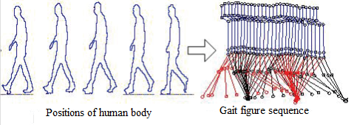

Figure 1: Gait Signature [5]

They address inter individual versus person dependent recognition. Recognition based on discrete affective states and recognition based on affective dimensions, and efficient feature extraction with respect to affect as compared to the temporal information by using Principal component analysis (PCA), kernel PCA, linear discriminant analysis, and general discriminant analysis in gait or extract relevant features for classification

3.PROBLEM DEFINITION

A physiological characteristic is a relatively stable physical characteristic, such as finger print, iris pattern, facial feature, hand, silhouette, etc. A physical characteristic such as hand, iris, and face have some limitations for identification; if someone wraps the face then it is difficult to identify the person and goggles create problem in iris identification. By using biometrics, it is possible to confirm or establish an individual’s identity based on “who she is,” rather than by “what she possesses” (e.g., an ID card) or “what she remembers” (e.g., a password).
Modules work to recognize a human by its gait cycle efficiently using the help of neural network approach which is more beneficial than other tools.

3.1 Scope Of Project
A physical characteristic such as hand, iris and face have same limitations for identification. With these three characteristics a person can easily hidden its identity. The interest in gait as a biometric is strongly motivated by the need for an automated recognition system for visual surveillance and monitoring applications.

3.2 Objectives
- Develop a method capable of performing recognition of individuals derived from a video sequence of a person walking which is near real time.
- Automatic extraction of relevant gait feature points should be available from a video sequence in order to automate the classification process
- Develop a method which is capable to recognize the person from low resolution images and in night mode also.

4. BIOMETRIC SYSTEM

Biometrics (or biometric authentication) refers to the identification of humans by their characteristics or traits. Biometrics is used in computer science as a form of identification and access control. It is also used to identify individuals in groups that are under surveillance. Biometric identifiers are the distinctive, measurable characteristics used to label and describe individuals. Biometric identifiers are often categorized as physiological versus behavioral characteristics. Physiological characteristics are related to the shape of the body. Examples include, but are not limited to ; fingerprint, face recognition, DNA, Palm print, hand geometry, iris recognition, retinaand odour/scent. Behavioral characteristics are related to the behavior of a person, including but not limited to: typing rhythm, gait, and voice. Some researchers have coined the term behaviometrics to describe the latter class of biometrics.
More traditional means of access control include token-based identification system, such as a driver's license or passport, and knowledge-based identification system, such as a password or personal identification number. Since biometric identifiers are unique to individuals, they are more reliable in verifying identity than token and knowledge-based methods; however, the collection of biometric identifiers raises privacy concerns about the ultimate use of this information.

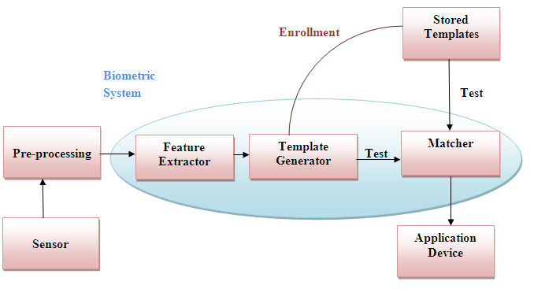
Fig 4.1:Logical block diagram of Biometric system

4.1 Biometric functionality
Many different aspects of human physiology, chemistry or behavior can be used for biometric authentication. The selection of a particular biometric for use in a specific application involves weighting of several factors. Seven factors are used when assessing the suitability of any trait for use in biometric authentication.
The basic block diagram of a biometric fig 4.1 is in the following two modes. In verification mode the system performs a one-to-one comparison of a captured biometric with a specific template stored in a biometric database in order to verify the individual is the person he/ she claims to be. Three steps are involved in person verification. In the first step, reference models for all the users are generated and stored in the model database. In the second step, some samples are matched with reference models to generate the genuine and impostor scores and calculate the threshold. Third step is the testing step. This process may use a smart card, username or ID number (e.g. PIN) to indicate which template should be used for comparison.Positive recognition is a common use of verification mode, "Where the aim is to prevent multiple people from using same identity".
In Identification mode the system performs one-to-many comparisons against a biometric database in an attempt to establish the identity of an unknown individual. The system will succeed in identifying the individual if the comparison of the biometric sample to a template in the database falls within a previously set threshold. Identification mode can be used either for 'positive recognition' (so that the user does not have to provide any information about the template to be used) or for 'negative recognition' of the person "Where the system establishes whether the person is one who she/he (implicitly or explicitly) denies to be".The latter function can only be achieved through biometrics since the other methods of personal recognition such as passwords, PINs or keys are ineffective.
The first time an individual uses a biometric system, it is called enrollment. During the enrollment, biometric information from an individual is captured and stored. In subsequent uses, biometric information is detected and compared with the information stored at the time of enrollment. Note that it is crucial that storage and retrieval of such systems themselves be secure if the biometric system is to be robust. The first block (sensor) is the interface between the real world and the system; it has to acquire all the necessary data. Most of the times it is an image acquisition system, but it can change according to the characteristics desired. The second block performs all the necessary pre-processing: it has to remove artifacts from the sensor, enhance the input (e.g. removing background noise), and use some kind of normalization, etc. In the third block necessary features are extracted. This step is an important step as the correct features need to be extracted in the optimal way. A vector of numbers or an image with particular properties is used to create a template. A template is a synthesis of the relevant characteristics extracted from the source. Elements of the biometric measurement that are not used in the comparison algorithm are discarded in the template to reduce the file size and to protect the identity of the enrollee.
If enrollment is being performed, the template is simply stored somewhere (on a card or within a database or both). If a matching phase is being performed, the obtained template is passed to a matcher that compares it with other existing templates, estimating the distance between them using any algorithm (e.g. Hamming distance). The matching program will analyze the template with the input. This will then be output for any specified use or purpose (e.g. entrance in a restricted area). Selection of biometrics in any practical application depends upon the characteristic measurements and user requirements. We should consider Performance, Acceptability, Circumvention, Robustness, Population coverage, Size and Identity theft deterrence in selecting a particular biometric. Selection of biometric based on user requirement should be made considering sensor availability, device availability, computational time and reliability, cost, sensor area and power consumption.

4.2 Gait Used for Biometric System
Recently the use of gait for people identification in surveillance applications has attracted researches from computer vision. The suitability of gait recognition for surveillance system emerges from the fact that gait can be perceived from a distance as well as its on-invasive nature. Gait is a very effective parameter for identification because the walking style of each human is unique. Gait is an attractive biometric feature for human identification at a distance, and recently has gained much interest from vision researchers. Although gait recognition is still anew biometric, it overcomes most of the limitations that other biometrics suffer from such as face, fingerprints and iris recognition which can be obscured in most situations where serious crimes are involved. Gait is a particular way or manner of moving on foot.
Compared with those traditional biometric features, such as face, iris, palm print and finger print, gait has many unique advantages such as non-contact, non-invasive and perceivable at a distance.As a biometric, gait has several attractive properties. Acquisition of images portraying an individual’s gait can be done easily in public areas, with simple instrumentation, and does not require the cooperation or even awareness of the individual under observation. Gait is a dynamic feature of humans which has been proven to have strong recognition abilities. However, it is greatly affected by varying viewing angles, surfaces, shoe and clothing types, passed time, and even emotional moods [1]. As stated above, gait has many advantages, especially unobtrusive identification at a distance, and night vision capability which is an important component in surveillance making it very attractive.
Current image-based human recognition methods, such as fingerprints, face, or iris biometric modalities, cannot accurately identify non-cooperating individuals at a distance in the real world, where surroundings are changing all the time [2]. The principal ascendency gait recognition offers, is that it can be applied without being noticed, i.e., without any attention or cooperation from the observed individual[5] .In addition to that, gait recognition also offers potential to be successfully done at low resolution imaging, where the walking individual encompasses few image pixels.A careful analysis of gait would reveal that it has two important components. The first is a structural component that captures the physical built of a person, e.g., body dimensions, length of limbs, etc. The second component is the motion dynamics of the body during a gait cycle
Gait analysis is the systematic study of animal locomotion, more specific as a study of human motion, using the eye and the brain of observers, augmented by instrumentation for measuring body movements, body mechanics, and the activity of the muscles[1] Gait analysis is used to assess, plan, and treat individuals with conditions affecting their ability to walk. It is also commonly used in sports biomechanics to help athletes run more efficiently and to identify posture-related or movement-related problems in people with injuries.The study encompasses quantification, i.e. introduction and analysis of measurable parameters of gaits, as well as interpretation, i.e. drawing various conclusions about the animal (health, age, size, weight, speed, etc.) from its gait.
A gait cycle corresponds to one complete cycle from rest (standing) position to-right-foot-forward-to-rest-to-left-foot forward- to-rest position. The movements within a cycle consist of the motion of the different parts of the body such as head, hands, legs, etc. The characteristics of an individual are reflected in the dynamics and periodicity of a gait cycle. Individual persons have their individual gait property and individual gait cycle which is identical in nature. Gait is the coordinated, cyclic combination of movements that result in human locomotion. The movements are coordinated in the sense that they must occur with a speciﬁc temporal pattern for the gait to occur. The movementsin a gait repeat as a walker’s cycle between steps with alternating feet. It is both the coordinated and cyclic nature of the motion that makes gait a unique phenomenon. Gait recognition is the term typically used in the computer community to refer to the automatic extraction of visual cues that characterize the motion of a walking person in video and is used for identification purposes in surveillance systems.
4.3 Approaches for Gait Recognition
Three common categories of gait recognition are appearance-based and model-based approaches and view based approach. Among the three, the appearance-based approaches suffer from changes in the appearance owing to the change of the viewing or walking directions. But, model-based approaches extract the motion of the human body by means of fitting their models to the input images. Model based ones are view and scale invariant and reflect in the kinematic characteristics of walking manner. In general, a gait is considered as being composed of a sequence of kinematic characteristics of human (i.e. human motion) and most systems in existence recognize it by the similarity of these characteristics. [1] And the view based approach is based on various view approaches and different views of images. In this paper we describe the model and view based approach.

4.4 Applications of Gait Analysis
Gait analysis is used to analyze the walking ability of humans and animals, so this technology can be used for the following applications:

Medical diagnostics
Pathological gait may reflect compensations for underlying pathologies, or be responsible for causation of symptoms in itself. Cerebral palsy and stroke patients are commonly seen in gait labs. The study of gait allows diagnoses and intervention strategies to be made, as well as permitting future developments in rehabilitation engineering. Aside from clinical applications, gait analysis is used in professional sports training to optimize and improve athletic performance.
Gait analysis techniques allow for the assessment of gait disorders and the effects of corrective orthopedic surgery. Options for treatment of cerebral palsy include the paralysis of spastic muscles using Botox or the lengthening, re-attachment or detachment of particular tendons. Corrections of distorted bony anatomy are also undertaken.

Biometric identification and forensics
Minor variations in gait style can be used as a biometric identifier to identify individual people. The parameters are grouped to spatial-temporal (step length, step width, walking speed, cycle time) and kinematic (joint rotation of the hip, knee and ankle, mean joint angles of the hip/knee/ankle, and thigh/trunk/foot angles) classes.
5. SYSTEM IMPLEMENTATION
5.1 Proposed Architecture
The proposed gait recognition system characterizes gait in terms of a gait signature computed directly from the sequence of silhouettes. The system can be seen as a generic pattern recognizer composed of the three main modules namely,
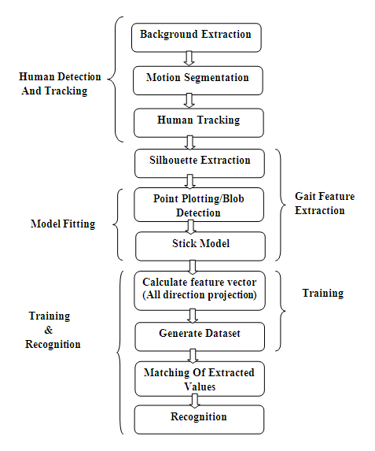
FigI5.1: Block diagram of proposed gait recognition system

5.1.1) Human detection and tracking
5.1.2) Feature Extraction
5.1.3) Training and Human recognition.

5.1.1 Human Detection and Tracking
Detection and tracking of human from a video sequence is the first step in gait recognition. The proposed system works with the assumption that the video sequence to be processed is captured by a static camera, and the only moving object in video sequence is the subject (person). Given a video sequence from a static camera, this module detects and tracks the moving silhouettes. This process comprises of two submodules:1) Foreground Modeling and 2) Human tracking [1]

5.1.1.1 Background Modeling
Background subtraction 2 is a technique in the fields of image processing and computer vision wherein an image's foreground is extracted for further processing (object recognition etc.). Generally an image's regions of interest are objects (humans, cars, text etc.) in its foreground. After the stage of image preprocessing (which may include image denoisingetc.) object localization is required which may make use of this technique. Background subtraction is a widely used approach for detecting moving objects in videos from static cameras. The rationale in the approach is that of detecting the moving objects from the difference between the current frame and a reference frame, often called a “background image”, or a “background model”. Background subtraction is mostly done if the image in question is a part of a video stream.
Extracting moving objects from a video sequence captured using a static camera is a fundamental and critical task in visual surveillance. A common approach to this critical task is to first perform background modeling to yield a reference model. By using the sequence of frames obtained from video, background can be modeled which can be later used to visualize moving objects in the video. Much research has been devoted to develop a background model that is robust and sensitive enough to identify moving object of interest. Some of the issues addressed in literature are,
1) Light changes: The background model should adapt to gradual illumination changes.
2) Moving background: The background model should be robust to changing background that is not of interest for visual surveillance such as waving trees and leaves, rain, snow, etc.

The primary assumption made here is that the camera is static, and the only moving object in video sequence is the walker. [7]
Fig 5.2: Foreground object
Fig 4.2 shows the foreground extracted object means by removing their background. The next step is to the track the moving silhouettes of a walking figure from the extracted binary foreground image. We adopt the morphological skeleton operator for human tracking. Skeletonization(Stick model) is defined as the process for reducing foreground regions in a binary image to a skeletal remnant that greatly preserves the degree and connectivity of the original region while removing a good number of the original foreground pixels
5.1.1.2 Foreground Extraction
After background modeling, moving objects from the video sequence must be segmented out for further processing. In the proposed system a simple motion detection method based on median value is adopted to model the background from the video Initially, the moving objects (human) are segmented and tracked in each frame of the given video sequence (tracking module). Then, the person’s identity is determined by training and testing on the extracted feature vectors (pattern recognition module)
5.1.1.3 Frame Differencing
Frame differencing is a technique where the computer checks the difference between two video frames. If the pixels have changed there apparently something was changing in the image (moving for example). Most techniques work with some blur and threshold, to differentiate real movement from noise because frame could differ too when light conditions in a room change (and camera auto focus, brightness correction etc.)This method does have two major advantages. One obvious advantage is the modest computational load. Another is that the background model is highly adaptive. Since the background is based solely on the previous frame, it can adapt to changes in the background faster than any other method (at 1/fps to be precise). As we'll see later on, the frame difference method subtracts out extraneous background noise (such as waving trees), much better than the more complex approximate median and mixture of Gaussians methods.

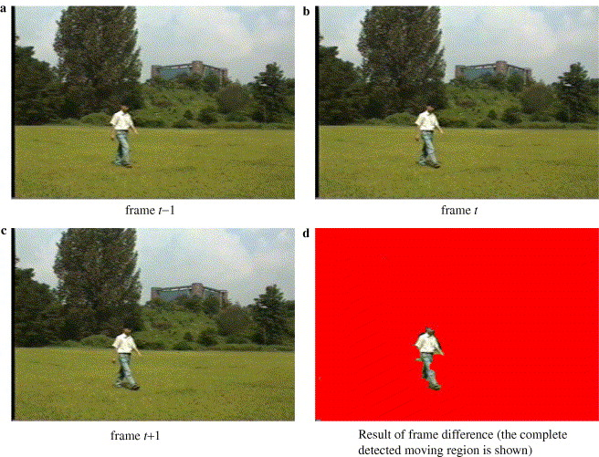
Fig 5.3: Images for frame differencing

Fig 5.3 shows the differences in different frames. In the gait recognition system frame differencing method is used for the observing the different frames in single videos. It is used for calculating the difference from two frames which helps in generating the dataset for training module. All the generated frames calculate their values as compared to previous one. It is easier to remove useless data or images from selected videos by using that.

5.1.2 Feature Extraction
Before the process of feature extraction, we first take the binary silhouette to estimate the gait cycle and thereby estimate the number of frames in a gait cycle. Knowing the number of frames in a gait cycle, the sequence of binary silhouettes will be divided into sub sequences of gait cycle length. We then consider frames in two gait cycles for feature extraction. This reduces the processing time considerably. The process of gait cycle estimation is briefly described below:
Human gait is treated as a periodic activity within each gait cycle. A single gait cycle can be regarded as the time between two identical events during the human walking and usually measured from heel strike to heel strike of one leg. There are two main phases called as stance phase and swing phase in the gait cycle. During stance phase, the foot is on the ground, whereas in swing phase that same foot is no longer in contact with the ground and the leg is swinging through in preparation for the next foot strike.
5.1.2.1 Silhouette Extraction
Before training and recognition, the silhouette shape of a human is first extracted by detecting and tracking persons in the surveillance area. Each image sequence, including a walking person's silhouette is converted into an associated temporal sequence of distance signals in the pre-processing stage. Silhouette representation is based on the projections of the silhouette, which are generated from a sequence of binary silhouette images

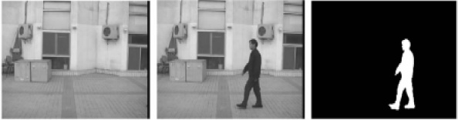
Fig 5.4 : Human silhouetted images
A gait cycle corresponds to one complete cycle from rest (standing) position to-right-foot-forward-to-rest-to left- foot-forward-to-rest position [2]. So, gait cycle estimation is particularly important for gait identification. Temporal components represent movement of the body over time. Stride length, Step length, are considered as temporal components. Stride length is the distance traveled by a person during one stride (or cycle) and can be measured as the length between the heels from one heel strike to the next heel strike on the same side Two step lengths (left plus right) make one stride length. Step length and stride lengths are computed by finding the number of frames in a step and stride. [7]
5.1.2.2 Model Fitting:
Model fitting is the procedure which is one of the pictorial representations that draws from their predicted values. Stick model n point/blob detection are the two parts which consist in model fitting. As model fitting we call the process by means we find the position of the silhouette and skeleton points in a new image by matching the model generated off-line in the blobs detected in the current image. First of all some image processing is performed to obtain the blobs corresponding to humans. Then we determinate the pose of the human .For model fitting background subtracted images are necessary of. The block diagram 5.5 shows the step by step procedure up to model fitting.
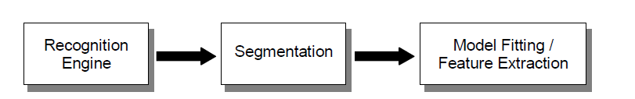

Fig 5.5: Block diagram for model fitting

The possible shapes generated by the combination of the primary modes of variation are not indicative of the training set due to its inherent non-linearity. In order to produce a model more accurate for practical applications, we divide the global training set in several cluster attending to the pose of the human figure. It is clear that the silhouette of a human figure taken from a frontal view is quite different from a lateral one.

5.1.2.2.1 Blob Detection:
Blob detection is the most critical state of the model fitting. Experimentally we usually have found distorted and split blobs corresponding to a single person. To improve the blob segmentation we first apply a model fitting to obtain a roughly contour and then we reduce the threshold value inside to detect more foreground pixels.
Fig.5.6 Blob detection
And for fitting the model we first calculate the different sigma values for plotting the points or blob. This process is repeated iteratively to convergence in a more reliable silhouette. Here generates the sigma values for blob detection. This sigma values plots the blob on different frames. All the plotted values stored in matrix form generate the dataset of different frames within a single video.
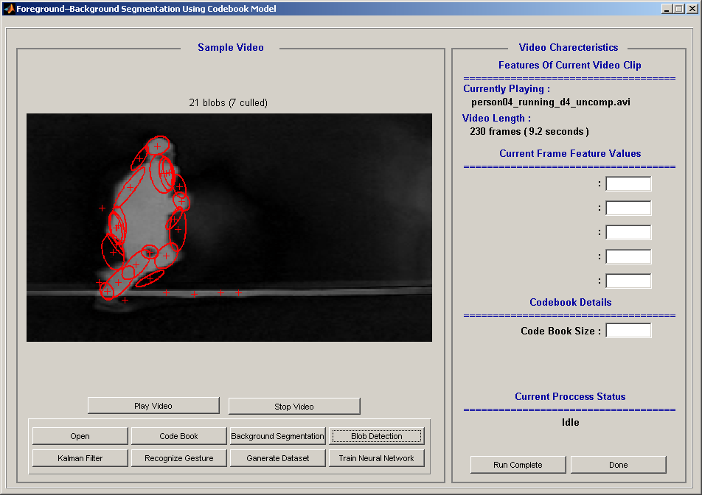
Fig 5.7: Blob detected image
5.1.2.2.2 Stick Model:
The body points are extracted from the gait silhouette data, and the 2D stick figures are obtained by connecting the body points Figure III.8 shows the extracted body silhouettes and their stick figures during one gait cycle. The gait signature can be defined as a sequence of the stick figures obtained from gait silhouette data during one gait cycle. The stick figure model is the most effective and well-defined representation method for kinematic gait analysis. Moreover, the stick figure is closely related to a joint representation, and the motion of the joints provides a key to motion estimation and recognition of the whole figure.
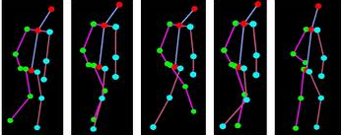
Fig 5.8 : Stick model
5.1.2.3 Training and Recognition:
The purpose of training is the 2D stick model silhouettes with the number of independent components to represent the original gait features from a high dimensional operates either as verification or as an identification system. A verification system authenticates a person’s identity by comparing the input biometric characteristic with a person’s own biometric data pre-stored in the system, so the system either rejects or accepts the submitted claim for authentication. An identification system recognizes an individual by searching the template database for a match [10]. Fig III.9 shows the training and recognition module schematically. However, a typical human gait identification system can be divided into training and recognition modules.
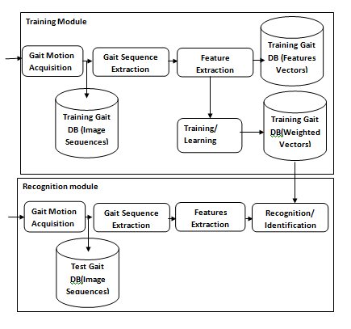

Fig 5.9 . Block Diagram of Gait Identification system
During the training phase, the gait motion is captured by a video camera for acquiring a digital representation of the characteristic. A feature extractor processes this representation to generate a more compact and expressive representation such as gait feature vector. The feature vectors for each person are then trained by a pattern recognition algorithm, and the trained results will be stored in a gait identification system’s database. [3]
In addition, the recognition module is responsible for identifying the person. During the recognition phase, the video camera captures the gait motion of the person to be identified, and it converts it into the same sort of feature vector as in training. After that, the feature vector will be submitted to the recognizer, which automatically computes it against the trained database to determine the identity of the individual. Figure 4 shows the block diagram of our gait identification system. To train and recognize the gait, a multi-layered neural network is used. The architecture of a typical biometric system also consists of same components. [3][5]
5.2 Neural Network for Gait Identification
Automated person identification is an important task in many security systems such as video surveillance and access control. It is well-known that biometrics are a powerful tool for reliable automated person identification [6] Automatic gait recognition is one of the newest of the emergent biometrics and has many advantages over other biometrics. The most notable advantage is that it does not require contact with the subjects nor does it require the subject to be near a camera. Various approaches [6] for the classification and recognition of human gait have been studied, but human gait identification is still a difficult task. Here, the gait feature vectors extracted from the gait signatures of the stored database are used for designing the neural network architecture [4].

The pattern classifier (or recognizer) is one of the most important components of the gait identification system. Many approaches to analyze and recognize gait have been used [3][7] k-nearest neighbors, fuzzy clustering, principal component analysis (PCA), canonical analysis, neural networks, fractal dynamics, and wavelet methods. Neural network methods facilitate gait analysis because of their highly flexible, inductive, non-linear modelling ability, unlike any other approaches. The strengths of PNN include simple training process, fast convergent rate and ease of implementation. The non-linear property of multi-layered neural networks is useful for the analysis of complicated gait variable relationships which have traditionally been difficult to model analytically for training multi-layered neural network, based on selective retraining and a dynamic adaptation of learning rate and momentum is employed to recognize the gait.
Fig.5.10Two-layered NN
An automated pattern recognition system minimally contains an input subsystem that accepts sample pattern vectors and a decision-maker subsystem that decides the classes to which an input pattern vector belongs [14]. If it also classifies, then it has a training phase in which it learns a set of classes of the population from a sample of pattern vectors, namely, it partitions the population into the subpopulations that are classes. A multi-layered feed-forward neural network is employed here to train and recognize the human gait. Figure 5 shows the network architecture. In the figure, X is the input feature vector with N elements, and O is the output vector with M elements. The neural network has one hidden layer of sigmoid nodes followed by an output layer of linear nodes. To train the network, the enhanced back-propagation algorithm is used. Also, the nodes of output layer are divided into two groups, and information about a maximum output node of each group is used to decode the output to an identification code of gait.

6. SOFTWARE DESCRIPTION
MATLABis a high-level language and interactive environment for numerical computation, visualization, and programming. Using MATLAB 11a we can analyze data, develop algorithms, and create models and applications. We can use MATLAB for a range of applications, including signal processing and communications, image and video processing, control systems, test and measurement, computational finance, and computational biology. More than a million engineers and scientists in industry and academia use MATLAB, the language of technical computing. In MATLAB there are no of toolboxes available for programming; some of them are image processing toolbox, neural network toolbox, video processing toolbox, fuzzy logic toolbox and DSP system toolbox etc.

Neural Network Toolboxprovides functions and apps for modeling complex nonlinear systems that are not easily modeled with a closed-form equation. Neural Network Toolbox supports supervised learning with feed forward, radial basis, and dynamic networks. It also supports unsupervised learning with self-organizing maps and competitive layers. With the toolbox you can design, train, visualize, and simulate neural networks. You can use Neural Network Toolbox for applications such as data fitting, pattern recognition, clustering, time-series prediction, and dynamic system modeling and control.

2. PC computer working under Windows XP
- 800 Mhz speed processor
- 512 Mo Memory (RAM)
- video card supporting Microsoft Direct 3D with 32 Mb Memory

6.1 Source Code

% MAINGUI M-file for MainGUI.fig
% MAINGUI, by itself, creates a new MAINGUI or raises the existing
% singleton*.
%
% H = MAINGUI returns the handle to a new MAINGUI or the handle to
% the existing singleton*.
%
% MAINGUI('CALLBACK',hObject,eventData,handles,...) calls the local
% function named CALLBACK in MAINGUI.M with the given input arguments.
%
% MAINGUI('Property','Value',...) creates a new MAINGUI or raises the
% existing singleton*. Starting from the left, property value pairs are
% applied to the GUI before MainGUI_OpeningFunction gets called. An
% unrecognized property name or invalid value makes property application
% stop. All inputs are passed to MainGUI_OpeningFcn via varargin.
%
% *See GUI Options on GUIDE's Tools menu. Choose "GUI allows only one
% instance to run (singleton)".
%
% See also: GUIDE, GUIDATA, GUIHANDLES

% Copyright 2002-2003 The MathWorks, Inc.

% Edit the above text to modify the response to help MainGUI

% Last Modified by GUIDE v2.5 04-Jun-2011 18:37:49

% Begin initialization code - DO NOT EDIT
gui_Singleton = 1;
gui_State = struct('gui_Name', mfilename, ...
'gui_Singleton', gui_Singleton, ...
'gui_OpeningFcn', @MainGUI_OpeningFcn, ...
'gui_OutputFcn', @MainGUI_OutputFcn, ...
'gui_LayoutFcn', [] , ...
'gui_Callback', []);
if nargin && ischar(varargin{1})
gui_State.gui_Callback = str2func(varargin{1});
end

if nargout
[varargout{1:nargout}] = gui_mainfcn(gui_State, varargin{:});
else
gui_mainfcn(gui_State, varargin{:});
end
% End initialization code - DO NOT EDIT

% --- Executes just before MainGUI is made visible.
function MainGUI_OpeningFcn(hObject, eventdata, handles, varargin)
% This function has no output args, see OutputFcn.
% hObject handle to figure
% eventdata reserved - to be defined in a future version of MATLAB
% handles structure with handles and user data (see GUIDATA)
% varargin command line arguments to MainGUI (see VARARGIN)
% Choose default command line output for MainGUI
handles.output = hObject;
% Update handles structure
guidata(hObject, handles);
warning off MATLAB:divideByZero;
% clearscrn(hObject, eventdata, handles);
% UIWAIT makes MainGUI wait for user response (see UIRESUME)
% uiwait(handles.figure1);

% --- Outputs from this function are returned to the command line.
function varargout = MainGUI_OutputFcn(hObject, eventdata, handles)
% varargout cell array for returning output args (see VARARGOUT);
% hObject handle to figure
% eventdata reserved - to be defined in a future version of MATLAB
% handles structure with handles and user data (see GUIDATA)

% Get default command line output from handles structure
varargout{1} = handles.output;

% --- Executes on button press in btnClr.
function ClrFeilds(hObject, eventdata, handles)
% hObject handle to btnClr (see GCBO)
% eventdata reserved - to be defined in a future version of MATLAB
% handles structure with handles and user data (see GUIDATA)
set(handles.txtStatus, 'String', 'Idle');
set(handles.txtProStatus, 'String', '');
set(handles.txtfilename , 'String', '');
set(handles.txtVdolen , 'String', '');

set(handles.btnPlayvdo, 'Enable', 'off');
set(handles.btnStopVdo, 'Enable', 'off');
axes(handles.axesVideo);
imshow(ones(10));
% --- Executes on button press in pushbutton12.

% --- Executes on button press in btnExit.
function btnExit_Callback(hObject, eventdata, handles)
% hObject handle to btnExit (see GCBO)
% eventdata reserved - to be defined in a future version of MATLAB
% handles structure with handles and user data (see GUIDATA)
closereq;

% --- Executes on button press in btnPlayvdo.
function btnPlayvdo_Callback(hObject, eventdata, handles)
% hObject handle to btnPlayvdo (see GCBO)
% eventdata reserved - to be defined in a future version of MATLAB
% handles structure with handles and user data (see GUIDATA)
global stopPlaying
numFrames = handles.nof;
video=handles.video;
set(handles.txtStatus, 'String', 'Wait');
set(handles.txtProStatus, 'String', 'Playing Video Clip');

for k = 1 : numFrames
axes(handles.axesVideo);
% video{a}=imresize(vidFrames(:,:,:,a),[180 320]);
imagesc(video{k});
axis image off
drawnow;

if stopPlaying==1
stopPlaying=0;
set(handles.txtStatus, 'String', 'Idle');
set(handles.txtProStatus, 'String', '');
break;
end
end
guidata(hObject, handles);
set(handles.txtStatus, 'String', 'Idle');
set(handles.txtProStatus, 'String', '');

% --- Executes on button press in btnStopVdo.
function btnStopVdo_Callback(hObject, eventdata, handles)
% hObject handle to btnStopVdo (see GCBO)
% eventdata reserved - to be defined in a future version of MATLAB
% handles structure with handles and user data (see GUIDATA)
global stopPlaying
stopPlaying=1;

% --- Executes on button press in btnOpen.
function btnOpen_Callback(hObject, eventdata, handles)
% hObject handle to btnOpen (see GCBO)
% eventdata reserved - to be defined in a future version of MATLAB
% handles structure with handles and user data (see GUIDATA)
set(handles.uipVec, 'Visible','Off');
ClrFeilds(hObject, eventdata, handles);
set(handles.txtStatus, 'String', 'Wait');
set(handles.txtProStatus, 'String', 'Opening Video Clip');
[fname, pname] = uigetfile( ...
{'*.mpg','Mpeg Files (*.mpg)'; ...
'*.*', 'All Files (*.*)'}, ...
'Pick a Video file');
filename=strcat(pname,fname);
handles.fname=filename;
movReader = mmreader(filename);
vidFrames = read(movReader);
numFrames = size(vidFrames,4);
handles.nof=numFrames ;
handles.fno=1;
txt=[ num2str(numFrames) ' frames ( ' num2str(movReader.Duration) ' seconds )'];
set(handles.txtVdolen,'String',txt);
set(handles.txtfilename,'String',fname);
for k = 1 : numFrames
video{k}=imresize(vidFrames(:,:,:,k),[180 320]);
end
handles.video=video;
axes(handles.axesVideo);
imagesc(video{1});
axis image off
drawnow;
set(handles.btnPlayvdo, 'Enable', 'on');
set(handles.btnStopVdo, 'Enable', 'on');
handles.vidFrames=vidFrames;
guidata(hObject, handles);
set(handles.txtStatus, 'String', 'Idle');
set(handles.txtProStatus, 'String', '');

function edit14_Callback(hObject, eventdata, handles)
% hObject handle to edit14 (see GCBO)
% eventdata reserved - to be defined in a future version of MATLAB
% handles structure with handles and user data (see GUIDATA)

% Hints: get(hObject,'String') returns contents of edit14 as text
% str2double(get(hObject,'String')) returns contents of edit14 as a double

% --- Executes during object creation, after setting all properties.
function edit14_CreateFcn(hObject, eventdata, handles)
% hObject handle to edit14 (see GCBO)
% eventdata reserved - to be defined in a future version of MATLAB
% handles empty - handles not created until after all CreateFcns called

% Hint: edit controls usually have a white background on Windows.
% See ISPC and COMPUTER.
if ispc && isequal(get(hObject,'BackgroundColor'), get(0,'defaultUicontrolBackgroundColor'))
set(hObject,'BackgroundColor','white');
end

% --- Executes on button press in btnBGDetect.
function btnBGDetect_Callback(hObject, eventdata, handles)
% hObject handle to btnBGDetect (see GCBO)
% eventdata reserved - to be defined in a future version of MATLAB
% handles structure with handles and user data (see GUIDATA)
set(handles.uipVec, 'Visible','Off');
video=handles.video;
try
load codebook;
handles.codebook=codebook;
u=size(codebook,2);
catch
handles.codebook={};
u=0;
end
Tm=fix(handles.nof/2);
cdbook={};ind=1;
for i=1:u
cm=codebook{i};
lambda=cm{4};
if lambda<=Tm
cdbook{ind}=cm;
ind=ind+1;
end
txtTimeMotDet as text
% str2double(get(hObject,'String')) returns contents of txtTimeMotDet as a double

% --- Executes during object creation, after setting all properties.
function txtTimeMotDet_CreateFcn(hObject, eventdata, handles)
% hObject handle to txtTimeMotDet (see GCBO)
% eventdata reserved - to be defined in a future version of MATLAB
% handles empty - handles not created until after all CreateFcns called

% Hint: edit controls usually have a white background on Windows.
% See ISPC and COMPUTER.
if ispc && isequal(get(hObject,'BackgroundColor'), get(0,'defaultUicontrolBackgroundColor'))
set(hObject,'BackgroundColor','white');
end

function txtTimeColQua_Callback(hObject, eventdata, handles)
% hObject handle to txtTimeColQua (see GCBO)
% eventdata reserved - to be defined in a future version of MATLAB
% handles structure with handles and user data (see GUIDATA)

% Hints: get(hObject,'String') returns contents of txtTimeColQua as text
% str2double(get(hObject,'String')) returns contents of txtTimeColQua as a double

% --- Executes during object creation, after setting all properties.
function txtTimeColQua_CreateFcn(hObject, eventdata, handles)
% hObject handle to txtTimeColQua (see GCBO)
% eventdata reserved - to be defined in a future version of MATLAB
% handles empty - handles not created until after all CreateFcns called

% Hint: edit controls usually have a white background on Windows.
% See ISPC and COMPUTER.
if ispc && isequal(get(hObject,'BackgroundColor'), get(0,'defaultUicontrolBackgroundColor'))
set(hObject,'BackgroundColor','white');
end

function txtTimeEdgDen_Callback(hObject, eventdata, handles)
% hObject handle to txtTimeEdgDen (see GCBO)
% eventdata reserved - to be defined in a future version of MATLAB
% handles structure with handles and user data (see GUIDATA)

% Hints: get(hObject,'String') returns contents of txtTimeEdgDen as text
% str2double(get(hObject,'String')) returns contents of txtTimeEdgDen as a double

% --- Executes during object creation, after setting all properties.
function txtTimeEdgDen_CreateFcn(hObject, eventdata, handles)
% hObject handle to txtTimeEdgDen (see GCBO)
% eventdata reserved - to be defined in a future version of MATLAB
% handles empty - handles not created until after all CreateFcns called

% Hint: edit controls usually have a white background on Windows.
% See ISPC and COMPUTER.
if ispc && isequal(get(hObject,'BackgroundColor'), get(0,'defaultUicontrolBackgroundColor'))
set(hObject,'BackgroundColor','white');
end

function txtTimeRet_Callback(hObject, eventdata, handles)
% hObject handle to txtTimeRet (see GCBO)
% eventdata reserved - to be defined in a future version of MATLAB
% handles structure with handles and user data (see GUIDATA)

% Hints: get(hObject,'String') returns contents of txtTimeRet as text
% str2double(get(hObject,'String')) returns contents of txtTimeRet as a double

% --- Executes during object creation, after setting all properties.
function txtTimeRet_CreateFcn(hObject, eventdata, handles)
% hObject handle to txtTimeRet (see GCBO)
% eventdata reserved - to be defined in a future version of MATLAB
% handles empty - handles not created until after all CreateFcns called

% Hint: edit controls usually have a white background on Windows.
% See ISPC and COMPUTER.
if ispc && isequal(get(hObject,'BackgroundColor'), get(0,'defaultUicontrolBackgroundColor'))
set(hObject,'BackgroundColor','white');
end

function txtTimeTot_Callback(hObject, eventdata, handles)
% hObject handle to txtTimeTot (see GCBO)
% eventdata reserved - to be defined in a future version of MATLAB
% handles structure with handles and user data (see GUIDATA)

% Hints: get(hObject,'String') returns contents of txtTimeTot as text
% str2double(get(hObject,'String')) returns contents of txtTimeTot as a double

function txtTshot_Callback(hObject, eventdata, handles)
% hObject handle to txtTshot (see GCBO)
% eventdata reserved - to be defined in a future version of MATLAB
% handles structure with handles and user data (see GUIDATA)

% Hints: get(hObject,'String') returns contents of txtTshot as text
% str2double(get(hObject,'String')) returns contents of txtTshot as a double

% --- Executes during object creation, after setting all properties.
function txtTshot_CreateFcn(hObject, eventdata, handles)
% hObject handle to txtTshot (see GCBO)
% eventdata reserved - to be defined in a future version of MATLAB
% handles empty - handles not created until after all CreateFcns called

% Hint: edit controls usually have a white background on Windows.
% See ISPC and COMPUTER.
if ispc && isequal(get(hObject,'BackgroundColor'), get(0,'defaultUicontrolBackgroundColor'))
set(hObject,'BackgroundColor','white');
end

pause(1)
if isempty(cx)
continue;
end
cx=cx';cy=cy';
u=size(cx,2);
if u<30
CX(1:u,count)=cx;
CY(1:u,count)=cy;
else
CX(1:u,count)=cx(1:u);
CY(1:u,count)=cy(1:u);
end
end
handles.CX=CX;
handles.CY=CY;
[P, xp, PP, K] = KalmanFilter(CX,CY,handles);
vecdata=[P, xp, PP, K];
handles.vecdata=vecdata;
guidata(hObject, handles);
uiwait(msgbox('Done'));
function varargout = oknoProgramu(varargin)

gui_Singleton = 1;
gui_State = struct('gui_Name', mfilename, ...
'gui_Singleton', gui_Singleton, ...
'gui_OpeningFcn', @oknoProgramu_OpeningFcn, ...
'gui_OutputFcn', @oknoProgramu_OutputFcn, ...
'gui_LayoutFcn', [] , ...
'gui_Callback', []);
if nargin && ischar(varargin{1})
gui_State.gui_Callback = str2func(varargin{1});
end

if nargout
[varargout{1:nargout}] = gui_mainfcn(gui_State, varargin{:});
else
gui_mainfcn(gui_State, varargin{:});
end
% End initialization code - DO NOT EDIT

% --- Executes just before oknoProgramu is made visible.
function oknoProgramu_OpeningFcn(hObject, eventdata, handles, varargin)
% This function has no output args, see OutputFcn.
% hObject handle to figure
% eventdata reserved - to be defined in a future version of MATLAB
% handles structure with handles and user data (see GUIDATA)
% varargin command line arguments to oknoProgramu (see VARARGIN)

% Choose default command line output for oknoProgramu
handles.output = hObject;

% Update handles structure
guidata(hObject, handles);

% UIWAIT makes oknoProgramu wait for user response (see UIRESUME)
% uiwait(handles.figure1);

% --- Outputs from this function are returned to the command line.
function varargout = oknoProgramu_OutputFcn(hObject, eventdata, handles)
% varargout cell array for returning output args (see VARARGOUT);
% hObject handle to figure
% eventdata reserved - to be defined in a future version of MATLAB
% handles structure with handles and user data (see GUIDATA)

% Get default command line output from handles structure
varargout{1} = handles.output;

% Pobranie zdjêæ
function pickPictures_Callback(hObject, eventdata, handles)
imagesPaths = [];
elements = guidata(hObject);
folders = uipickfiles;

if(iscell(folders) == 1)
imagesPaths = cell2mat(folders(:));
if isfield(elements,'net') && isfield(elements,'H') && isfield(elements,'W') && isfield(elements,'T')
guidata(hObject,struct('images',imagesPaths, 'net',elements.net, 'H', elements.H, 'W', elements.W,'T',elements.T));
elseif isfield(elements,'H') && isfield(elements,'W') && isfield(elements,'T')
guidata(hObject,struct('images',imagesPaths,'H', elements.H,'W',elements.W,'T',elements.T));
elseif isfield(elements,'net')
guidata(hObject,struct('net',elements.net,'images',imagesPaths));
else
guidata(hObject,struct('images',imagesPaths));
end
end

% Dodanie zdjeæ do bazy danych
function addToDatabase_Callback(hObject, eventdata, handles)
prompt = {'Ktora klasa:'};
dlg_title = 'Input';
num_lines = 1;
defaultans = {'1'};
answer = inputdlg(prompt,dlg_title,num_lines,defaultans);
elements = guidata(hObject);
imagesPaths = elements.images;

X = [];
H = [];
W = [];
A = [];
B = [];
T =[];

if(isempty(imagesPaths) ~= 1)
for i=1:size(imagesPaths)
imm = imread(imagesPaths(i,:));
rec = calculateRectangle(imm);
A = [rec(3)];
H = [H ; A];
A = [rec(4)];
W = [W ; A];
B = str2double(answer);
T = [T ; B];
end

if isfield(elements,'H') && isfield(elements,'W')
H1 = elements.H;
H = [H1 ; H];
W1 = elements.W;
W = [W1 ; W];
T1 = elements.T;
T = [T1 ; T];
end

if isfield(elements,'net')
guidata(hObject,struct('net',elements.net,'H',H,'W',W,'T',T));
else
guidata(hObject,struct('H',H,'W',W,'T',T));
end
end

% --- Usuniecie bazy obrazów
function deleteFromDatabase_Callback(hObject, eventdata, handles)
guidata(hObject,0);

% --- Rozpoznawanie obrazu
function recognize_Callback(hObject, eventdata, handles)

elements = guidata(hObject);

if isfield(elements,'net')
net = elements.net;
else
disp('Nie nauczono sieci');
return
end

if isfield(elements,'images')
imagesPaths = elements.images;
else
disp('Nie wybrano zdjêæ');
return
end

X = [];
A = [];
T =[];
W = [];
H = [];
if(isempty(imagesPaths) ~= 1)
for i=1:size(imagesPaths)
imm = imread(imagesPaths(i,:));
rec = calculateRectangle(imm);
T = [T ; i];
A = [rec(3)];
H = [H ; A];
A = [rec(4)];
W = [W ; A];
end
W = transpose(W);
H = transpose(H);
T = transpose(T);

X = [W;H];
X = transpose(X);
T = num2cell(T);

X1 = tonndata(X, false, false);
netc = closeloop(net);
view(netc)
[Xs,Xi,Ai,Ts] = preparets(netc,X1,{},T);
y = netc(Xs,Xi,Ai);
wynik = y(length(y));
wynik = wynik{:}
wynik = round(wynik);
message = strcat('osoba numer: ',num2str(wynik));
msgbox(message,'Wynik');
end

% Uczy sieæ z danych przechowywanych w bazie
function learnDatabase_Callback(hObject, eventdata, handles)
elements = guidata(hObject);
X = [];
X1 = [];
T1 = [];
net = narxnet(1:2,1:2,20);
net.divideFcn = 'dividerand';
W = elements.W;
H = elements.H;
T = elements.T;

W = transpose(W);
H = transpose(H);
T = transpose(T);

X = [W;H];
X = transpose(X);
T1 = num2cell(T);

X1 = tonndata(X, false, false);
[Xs,Xi,Ai,Ts] = preparets(net,X1,{},T1);

net = train(net,Xs,Ts,Xi,Ai);
netc = closeloop(net);
[Xs,Xi,Ai,Ts] = preparets(netc,X1,{},T1);
net = train(netc,Xs,Ts,Xi,Ai);
view(net)
Y = net(Xs,Xi,Ai);
guidata(hObject,struct('net',net));

function edit1_Callback(hObject, eventdata, handles)
set(handles.Edit,'String',num_class);

% --- Executes during object creation, after setting all properties.
function Edit_CreateFcn(hObject, eventdata, handles)

% Hint: edit controls usually have a white background on Windows.
% See ISPC and COMPUTER.
if ispc && isequal(get(hObject,'BackgroundColor'), get(0,'defaultUicontrolBackgroundColor'))
set(hObject,'BackgroundColor','white');
end

function test1_Callback(hObject, eventdata, handles)

% Hints: get(hObject,'String') returns contents of test1 as text
% str2double(get(hObject,'String')) returns contents of test1 as a double

% --- Executes during object creation, after setting all properties.
function test1_CreateFcn(hObject, eventdata, handles)
% hObject handle to test1 (see GCBO)
% eventdata reserved - to be defined in a future version of MATLAB
% handles empty - handles not created until after all CreateFcns called

% Hint: edit controls usually have a white background on Windows.
% See ISPC and COMPUTER.
if ispc && isequal(get(hObject,'BackgroundColor'), get(0,'defaultUicontrolBackgroundColor'))
set(hObject,'BackgroundColor','white');
end

% --- Executes on button press in pushbutton25.
function pushbutton25_Callback(hObject, eventdata, handles)
% hObject handle to pushbutton25 (see GCBO)
% eventdata reserved - to be defined in a future version of MATLAB
% handles structure with handles and user data (see GUIDATA)
btnOpen_Callback(hObject, eventdata, handles);
pause(5);
btnBGDetect_Callback(hObject, eventdata, handles);
pause(5);
pushbutton24_Callback(hObject, eventdata, handles);
pause(5);
pushbutton20_Callback(hObject, eventdata, handles);
pause(5);
pushbutton22_Callback(hObject, eventdata, handles);

7. SIMULATION RESULT

7.1 Result

Extensive experimentation has been carried out to portray the effectiveness of the proposedsystem and discussions on the results are presented in thesub-sections below. When we run the project the screen appears where the option is available toopen the video.Select on that button and set the path of image then video is open in the given GUI. The .avi file format is easily supported by MATLAB.

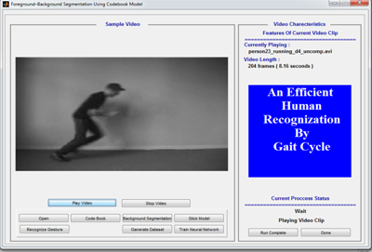
(a)

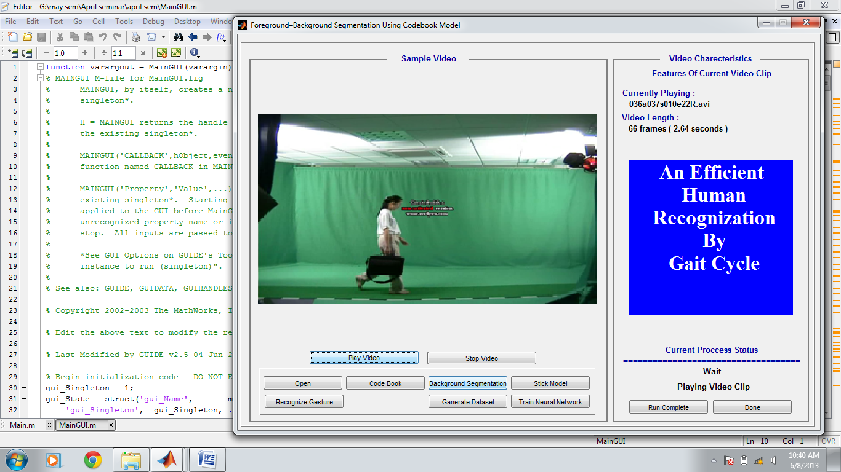
(b)
Fig 7.1 Selected video

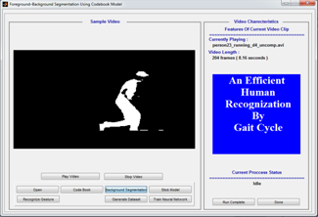
(c)

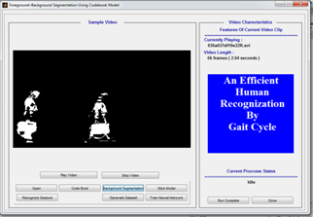
(d)
Fig 7.2 Background Segemented image
The background selected image is shown in fig.This is the subtracted image of previous one. shows the selected video a and b.These are two different videos and their results are shown one by one . Fig c and d are the background segmented videos from the selected videos and their total frames are shown on window. The kelman filter for filtering the unwanted and noisy frames is used.[P, xp, PP, K] = KalmanFilter(CX,CY,handles);
This is the kelman filter function used in coding for removing the unwantwd frames.

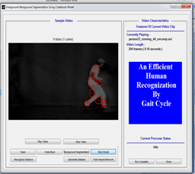

(e)
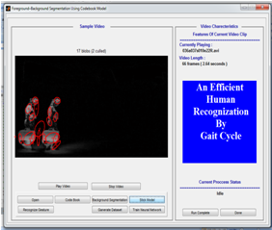
(f)
Fig7.3: Blob detected images

MotionVector=handles.MotionVector;
numFrames=size(MotionVector,3);
CX=zeros(30,numFrames);CY=zeros(30,numFrames);
for count = 1:numFrames
fr = MotionVector(:,:,count);
axes(handles.axesVideo);
imshow(fr);
pause(0.2);
[cx, cy, X, Y, Xbar, Ybar] = FeatBlobDetect(fr,handles);
Fig IV.3 shows the blob detected images.The single video is divided into more than 100 framesbut only a few frames are selected for generating the datasetbecause some frames are noisy so they do not give proper values.As above ,the kelman filter is used for removing the noisy frames.The FeatBlobDetect function is used to fit the blobs on the selectrd frames.
for k = 1 : numFrames
video{k}=imresize(vidFrames(:,:,:,k),[180 320]);
This fuction is used for the calculating the total number of frames in a video.
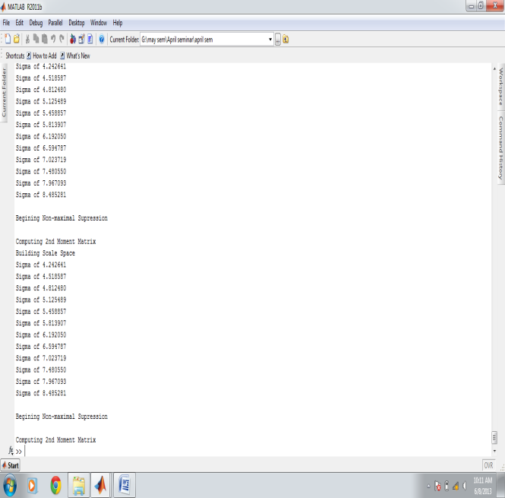
(g)
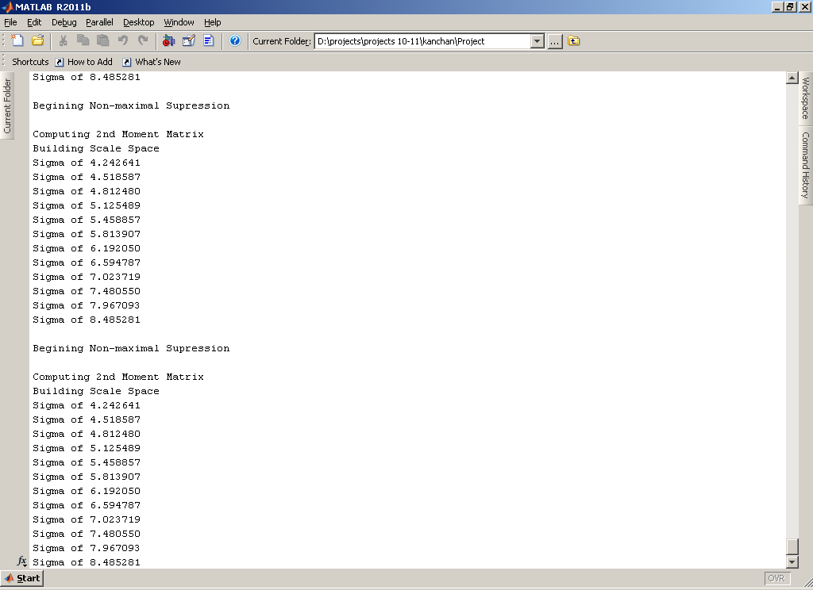
(h)
Fig 7.4:Sigma values

Fig IV.4 shows the sigma values which are generated for the blobs.This value selects the center value of a single blob.In the selected frames from window the blobs are generated on that and the sigma value of that particular portion in the frame is found out.After the blob detection we generated the stick model by connectiing the all center point values which were generated in blobs.By connecting the centers of blobs we generated the stick
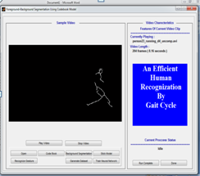

(i)
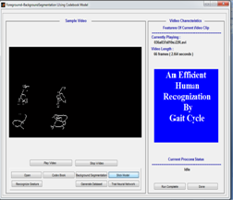
(j)
Fig 7.5 Generated Stick model

Bw=(fr>0.3);
axes(handles.axesVideo);
I=bwmorph(Bw,'thin',inf);
imshow(I);
Fig IV.5 shows the stick model on two different videos.This is the feature extraction part in proposed methodology.Here the gait cycle estimation method has started.After that the training part of videos has started once we genarated the dataset. Morphological function is applied in the operation n times. n can be Inf, in which case the operation is repeated until the image no longer changes.

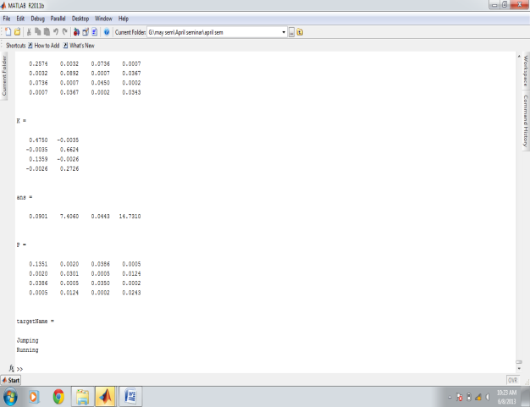
(k)

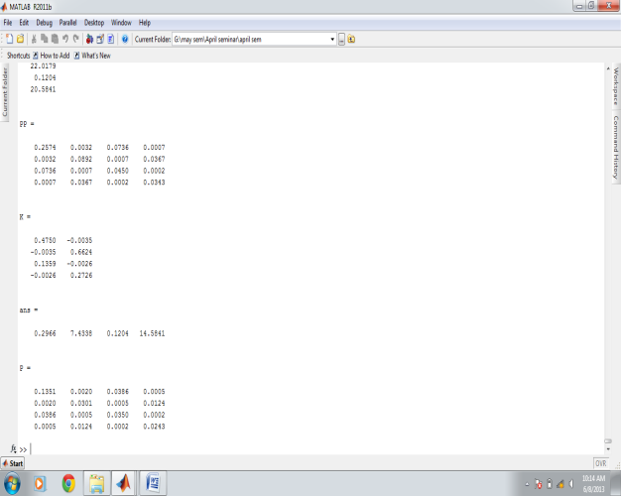
(l)
Fig.7.6 Generated Dataset
Fig 7.6 represents the generated dataset for those two selected videos.This video dataset is generated folderwise.Suppose this method is used for any institution n for applying this biometric authirizatin system First we take the walking videos or footages from still camera and differentiate all those videos by the name of employers.This dataset is used for training the data. Next time when the specified employee comes in the next video, this is the recognition module of that scheme.Then the new pattern and previous patternare compared.If the trained dataset is available then system recognizes this specific person by his/her name ontrained dataset,

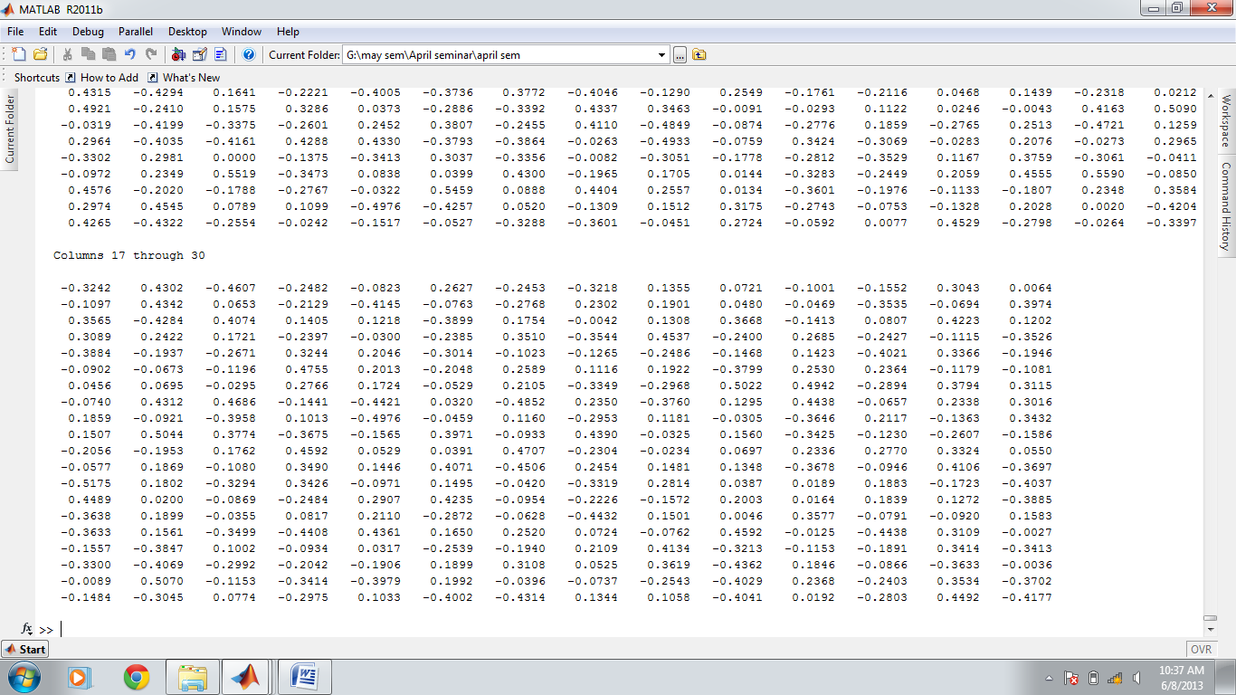

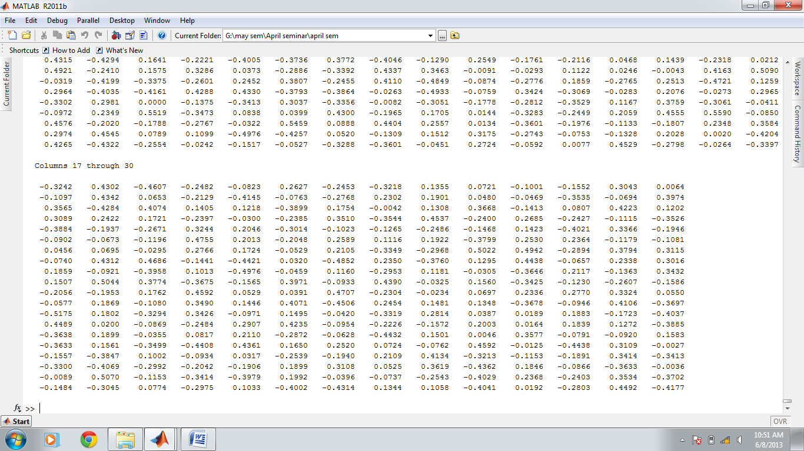
Fig 7.7:Neural Network window
After training the neural network, the different weights are assigned to neural network layers. This will be shown after applying the best net command on the MATLAB editor window, for that first we need to load the neural network on videos. On the other hand, the mean and variation of the gait angles for single sequence of each subject are extracted asfeatures. The variation of the gait angles can be obtained by standard derivation during one gait cycle. Trajectories of gait figure contain kinematic characteristics on human movement. The kinematic characteristics include linear and angular position, their displacements and the time derivatives, notably the linear and angular velocities and accelerations.
Fig IV.8 shows the neural network window which trains this generated dataset and acquires their position. This neural network assigns different weights to the hidden layer of multilayered feed forward network, which presents the one input layer where input is the stick value means the co-ordinates of the stick.
loadAllData;
best_net=trainNeural(AllData);

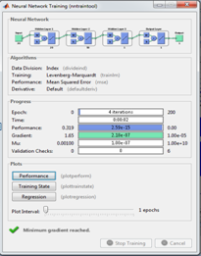
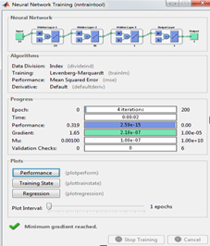

Fig 7.8:Training neural network
Figure IV.8 shows the two training neural network windows for the two selected videos. Fig IV.9 shows the training plot set which shows graphically. This graph shows the plotting of values which is trained by neural network and the function shows the load function of neural network
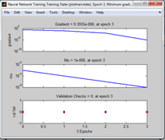
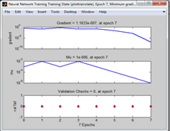
Fig 7.9:Trained plot set

After training the neural network the important work is to recognize this dataset. Then we apply the recognized command on trained data. This module compares all the new data or pattern with the stored trained dataset which is calculated in the previous steps. If the matching dataset is found in stored video set then this new pattern shows the result of recognition. Similarly the above calculated video dataset are trained and they show their results below.
.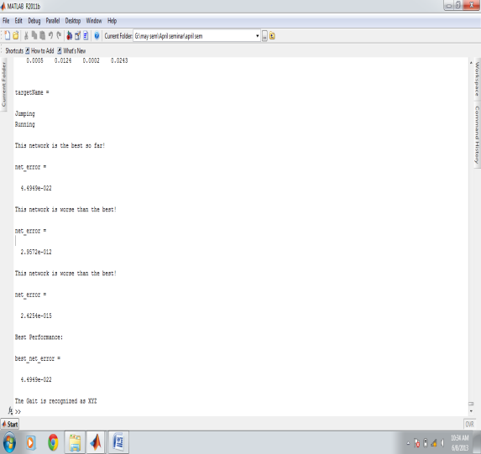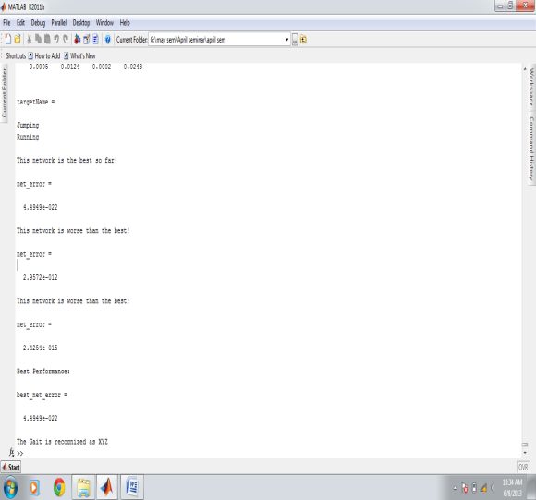

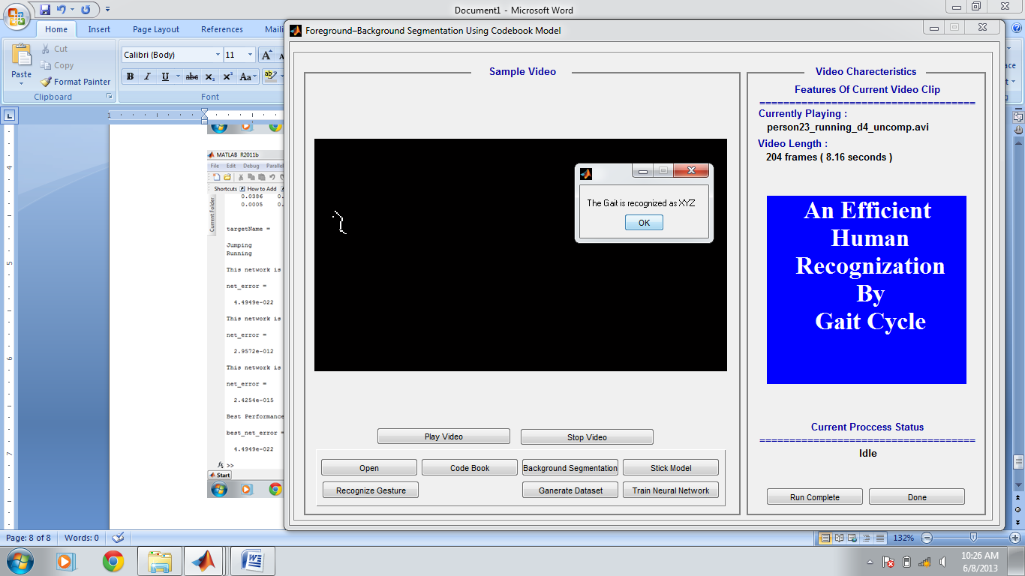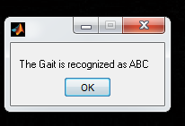
Fig 7.10: Recognition window
The fig IV.10 shows the recognized windows and shows the results of the videos which are selected for recognition of the pattern.
SignVector=handles.vecdata;
s=SignVector(:);s=dsort(s);
res=sim(best_net,s(1:30))*maxt;
loadtargetName;
recAs=targetName(round(res),:);
Finallythis method shows the result that in video a is the person XYZ and video b is the person ABC.By using this model based approch by using the neural network we find the recognition rate upto 85-90%.This recognition helps in biometric authentication.

7.2 Advantages
Advantages:
- It is non contactable.
- It is non invasive.
- It can hidden from subject easily.

7.3 Application
- Identifies the person from low resolution images.
- This is the new biometric authorization system which does not need to contact any device for authentication.
- This is the one of the approach which is used for security purpose in any surveillance are military areas, banks and parks etc.

8. Conclusion& Future Scope
8.1 Conclusion

Hence, “An Efficient Human Recognition By Gait Cycle”
With mounting demands for visual surveillance systems, human identification at a distance has recently emerged asan area of significant interest. Gait is being considered asan impending behavioral feature and many allied studies have illustrated that it can be used as a valuable biometricfeature for human recognition.
Gait is being considered as an impending behavioral feature and many allied studies have illustrated that it can be used as a valuable biometric feature for human recognition. The development of computer vision techniques has also assured that vision based automatic gait analysis can be gradually achieved. The proposed system has been tested on the gait databases and, the extensive experimental results on outdoor image sequences demonstrated that the proposed system possesses a pleasing recognition performance.
The approach for both gait cycle estimation and gait recognition is also fully automatic for real-time applications. The proposed recognition approach also achieves highly competitive performance with respect to the major published recognition approaches. To improve the performance of the model we develop a human gait analysis to take into account temporal dynamic to track human body. The incorporation of temporal constraints on the model increase reliability and robustness. By using this approach we develop a recognition approach upto 90%.This method identifies the person more accurately than the other approaches which develop as early.

8.2: Future Scope
There is immense scope for future applications of this method. We can develop this method for multiple people.If at a time two persons walk together thenboth of them can be recognized easily.

9. References
9.1References
1.M. Pushpa Rani1 and G.Arumugam “An efficient gait recognition system for human
Identification”International journal of computer science & information
technology, Vol.2, No.1 Feb-2010
2.MuratEkinci“Human Identification Using Gait”Turk J ElecEngin, VOL.14, NO.2 2006, cT¨UBITAK
3. Amit Kale, AravindSundaresan, A. N. Rajagopalan, Naresh P. Cuntoor, Amit K. Roy-Chowdhury, Volker Krüger, and Rama Chellappa “Identification of Humans Using Gait” IEEE TRANSACTIONS ON IMAGE PROCESSING, VOL. 13, NO. 9, SEPTEMBER 2004 1163
4.L.R. Sudha 1, R. Bhavani “Biometric Authorization System by Video Analysis
of Human Gait in Controlled Environments”IEEE-International Conference on Recent Trends in Information Technology, ICRTIT 2011
[5] Qiang Chen, Yunhong Wang, Zheng Liu, Qingjie Liu, Di Huang, "Feature map pooling for cross-view gait recognition based on silhouette sequence images", Biometrics (IJCB) 2017 IEEE International Joint Conference on, pp. 54-61, 2017.
[6] Zhiyong Liu “Gait recognition using Active Energy Image and Gabor wavelet” , 2016 9th International Congress on Image and Signal Processing, BioMedical Engineering and Informatics (CISP-BMEI).

[7] Xue Hongye ; Hao Zhuoya, “ Gait recognition based on gait energy image and linear discriminant analysis”, 2015 IEEE International Conference on Signal Processing, Communications and Computing (ICSPCC)
[8] Y. D. Guan, R. F. Zhu, J. Y. Feng, K. Du, X. R. Zhang, "Research on Algorithm of Human Gait Recognition Based on Sparse Representation", Instrumentation & Measurement Computer Communication and Control (IMCCC) 2016 Sixth International Conference on, pp. 405-410, 2016.
[9] Chao Li, Shouqian Sun, Xin Min, Wenqian Lin, Binling Nie, Xianfu Zhang, "End-to-end learning of deep convolutional neural network for 3D human action recognition", Multimedia & Expo Workshops (ICMEW) 2017 IEEE International Conference on, pp. 609-612, 2017.
[10] Tanmay T. Verlekar, Paulo L. Correia, Luís D. Soares, "View-invariant gait recognition system using a gait energy image decomposition method", Biometrics IET, vol. 6, no. 4, pp. 299-306, 2017.

